Coordonnées station: | Lat 50.6970, Lon 5.2248
Magnitude: | M 6.0
Region: | HOKKAIDO, JAPAN REGION
Date heure épicentre: | 2014-08-10 03:43:19.80 UTC
Localisation: | Lat 41.2400, Lon 142.3000
Profondeur: | 60.0 km
Distance: | ~ 8999.6 km (80.94 deg)
Azimut: | 31.23 deg
Incidence: | 58.77 deg

Modèle: iasp91 |  |  |  |  | Modèle: ak135
Type | Durée t | Date Heure UTC | Take off | | | Type | Durée t | Date Heure UTC | Take off
Onde | sssss.ms | YYYY-MM-JJ HH:mm:ss.ms | (deg) | | | Onde | sssss.ms | YYYY-MM-JJ HH:mm:ss.ms | (deg)
 |  |  |  | |
P | 726.713 | 2014-08-10 03:55:26.51 | 22.92 | | | P | 726.675 | 2014-08-10 03:55:26.47 | 22.95 | |
PcP | 733.036 | 2014-08-10 03:55:32.83 | 18.60 | | | PcP | 733.245 | 2014-08-10 03:55:33.04 | 18.60 | |
pP | 743.443 | 2014-08-10 03:55:43.24 | 156.94 | | | pP | 743.402 | 2014-08-10 03:55:43.20 | 156.91 | |
sP | 750.341 | 2014-08-10 03:55:50.14 | 167.42 | | | sP | 750.009 | 2014-08-10 03:55:49.80 | 167.38 | |
PP | 910.936 | 2014-08-10 03:58:30.73 | 37.14 | | | PP | 911.174 | 2014-08-10 03:58:30.97 | 37.16 | |
PKiKP | 1053.558 | 2014-08-10 04:00:53.35 | 6.55 | | | PKiKP | 1053.763 | 2014-08-10 04:00:53.56 | 6.54 | |
pPKiKP | 1071.205 | 2014-08-10 04:01:11.00 | 173.46 | | | pPKiKP | 1071.410 | 2014-08-10 04:01:11.21 | 173.46 | |
sPKiKP | 1077.898 | 2014-08-10 04:01:17.69 | 176.36 | | | sPKiKP | 1077.816 | 2014-08-10 04:01:17.61 | 176.36 | |
SKiKP | 1262.119 | 2014-08-10 04:04:21.91 | 3.77 | | | SKiKP | 1262.513 | 2014-08-10 04:04:22.31 | 3.77 | |
S | 1330.101 | 2014-08-10 04:05:29.90 | 25.03 | | | S | 1329.654 | 2014-08-10 04:05:29.45 | 25.14 | |
SKSac | 1338.668 | 2014-08-10 04:05:38.46 | 16.23 | | | SKSac | 1339.907 | 2014-08-10 04:05:39.70 | 16.26 | |
SKKSac | 1341.657 | 2014-08-10 04:05:41.45 | 17.76 | | | SKKSac | 1342.253 | 2014-08-10 04:05:42.05 | 17.89 | |
ScS | 1348.090 | 2014-08-10 04:05:47.88 | 19.39 | | | ScS | 1348.482 | 2014-08-10 04:05:48.28 | 19.44 | |
pS | 1351.278 | 2014-08-10 04:05:51.07 | 129.99 | | | pS | 1350.506 | 2014-08-10 04:05:50.30 | 129.81 | |
sS | 1359.007 | 2014-08-10 04:05:58.80 | 154.83 | | | sS | 1357.938 | 2014-08-10 04:05:57.73 | 154.72 | |
pSKSac | 1361.758 | 2014-08-10 04:06:01.55 | 149.67 | | | pSKSac | 1362.701 | 2014-08-10 04:06:02.50 | 149.63 | |
sSKSac | 1368.820 | 2014-08-10 04:06:08.62 | 163.70 | | | sSKSac | 1369.470 | 2014-08-10 04:06:09.27 | 163.66 | |
SPn | 1374.977 | 2014-08-10 04:06:14.77 | 30.47 | | | SPn | 1374.416 | 2014-08-10 04:06:14.21 | 30.51 | |
PnS | 1383.438 | 2014-08-10 04:06:23.23 | 65.17 | | | PnS | 1382.562 | 2014-08-10 04:06:22.36 | 65.14 | |
SS | 1645.068 | 2014-08-10 04:10:44.86 | 37.32 | | | SS | 1643.683 | 2014-08-10 04:10:43.48 | 37.43 | |
PKKPdf | 1833.886 | 2014-08-10 04:13:53.68 | 6.77 | | | PKKPdf | 1834.861 | 2014-08-10 04:13:54.66 | 6.84 | |
PKKPbc | 1845.640 | 2014-08-10 04:14:05.44 | 9.70 | | | PKKPbc | 1845.486 | 2014-08-10 04:14:05.28 | 9.44 | |
SKKPdf | 2042.448 | 2014-08-10 04:17:22.24 | 3.64 | | | SKKPdf | 2043.667 | 2014-08-10 04:17:23.46 | 3.67 | |
PKKSdf | 2049.141 | 2014-08-10 04:17:28.94 | 6.55 | | | PKKSdf | 2050.073 | 2014-08-10 04:17:29.87 | 6.59 | |
SKKPbc | 2057.397 | 2014-08-10 04:17:37.19 | 5.02 | | | SKKPbc | 2057.182 | 2014-08-10 04:17:36.98 | 4.97 | |
PKKSbc | 2064.106 | 2014-08-10 04:17:43.90 | 9.03 | | | PKKSbc | 2063.603 | 2014-08-10 04:17:43.40 | 8.94 | |
SKKSdf | 2257.494 | 2014-08-10 04:20:57.29 | 3.52 | | | SKKSdf | 2258.637 | 2014-08-10 04:20:58.43 | 3.53 | |
P'P'df | 2329.527 | 2014-08-10 04:22:09.32 | 7.55 | | | P'P'df | 2330.516 | 2014-08-10 04:22:10.31 | 7.64 | |
S'S'df | 3186.089 | 2014-08-10 04:36:25.88 | 3.79 | | | S'S'df | 3187.346 | 2014-08-10 04:36:27.14 | 3.84 | |
S'S'ac | 3197.257 | 2014-08-10 04:36:37.05 | 5.42 | | | S'S'ac | 3197.443 | 2014-08-10 04:36:37.24 | 5.28 | |
 |  |  |  | |
Love | 2479.216 | 2014-08-10 04:24:39.01
Rayleigh | 2999.852 | 2014-08-10 04:33:19.65

Mes courbes (direct) :
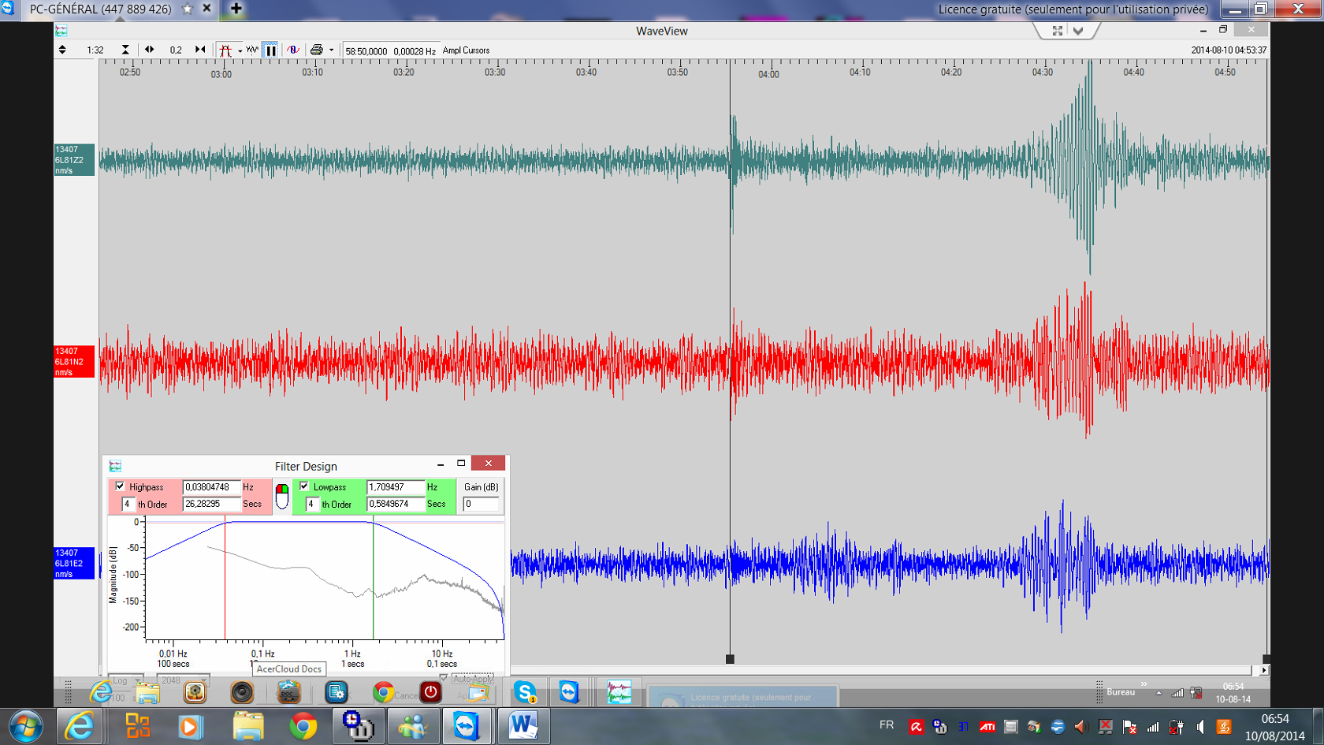

Journal tambour Membach (ORB) :
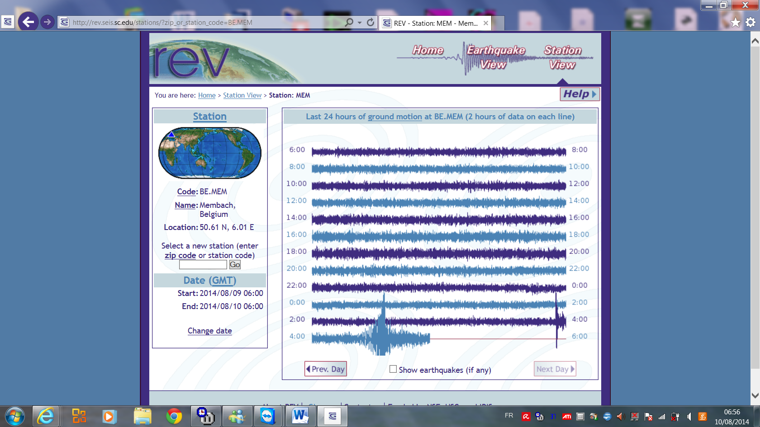

Cdt,

Daniel

